**PRACTICAL NO. 1**

Perform the steps of the installation in wordpress :

Step 1: starting module:-

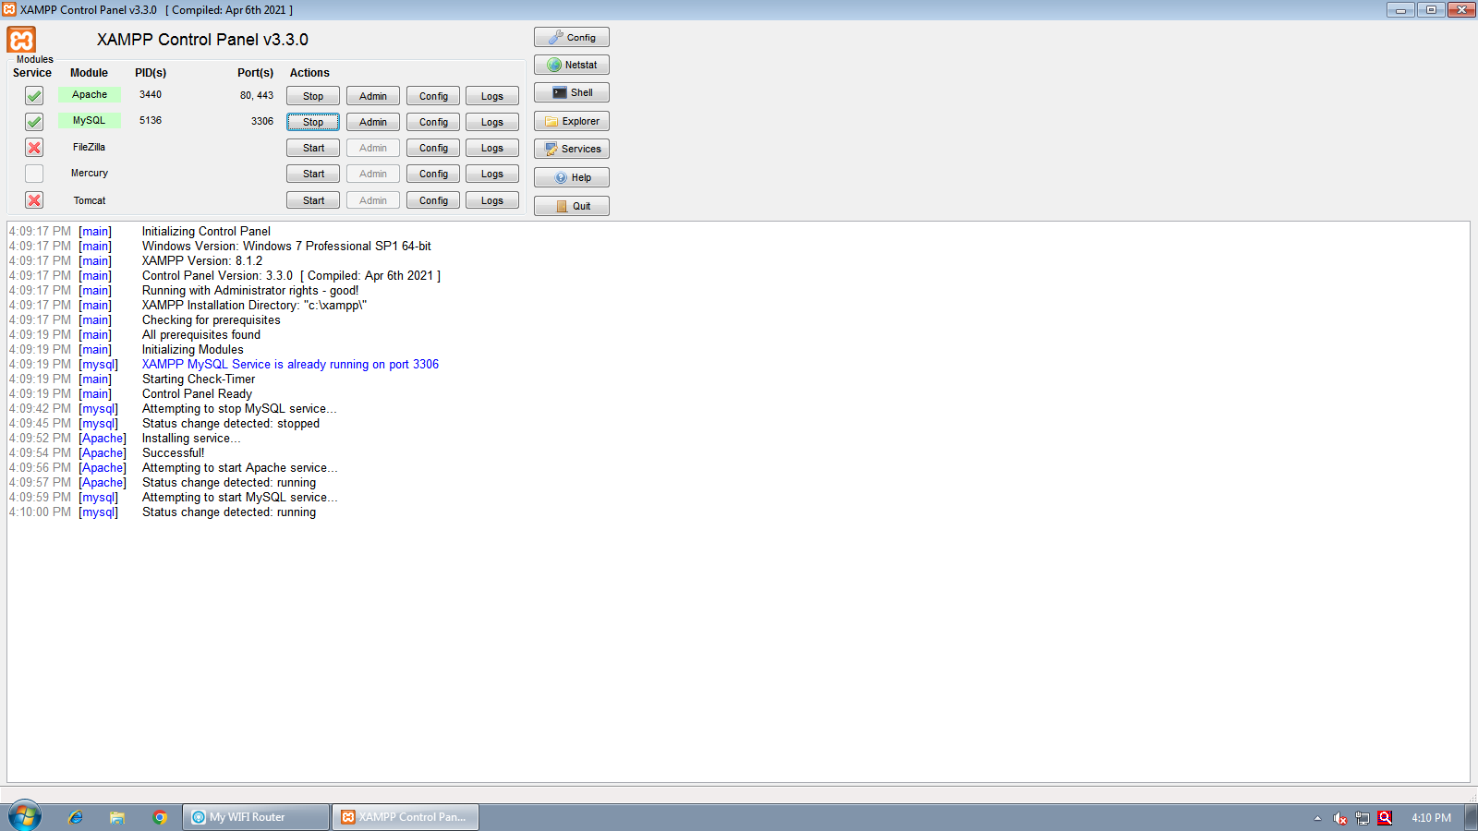

Step 2: download and extract:-

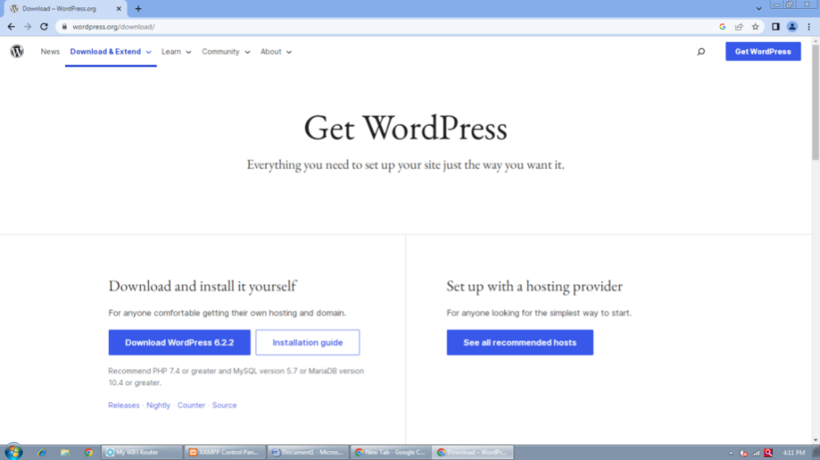

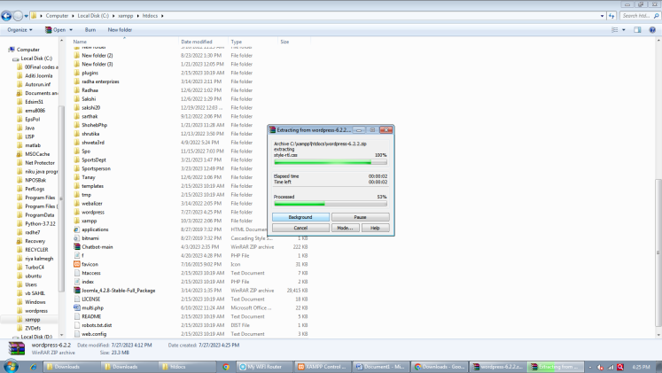

Step 3:-create the database and user:-

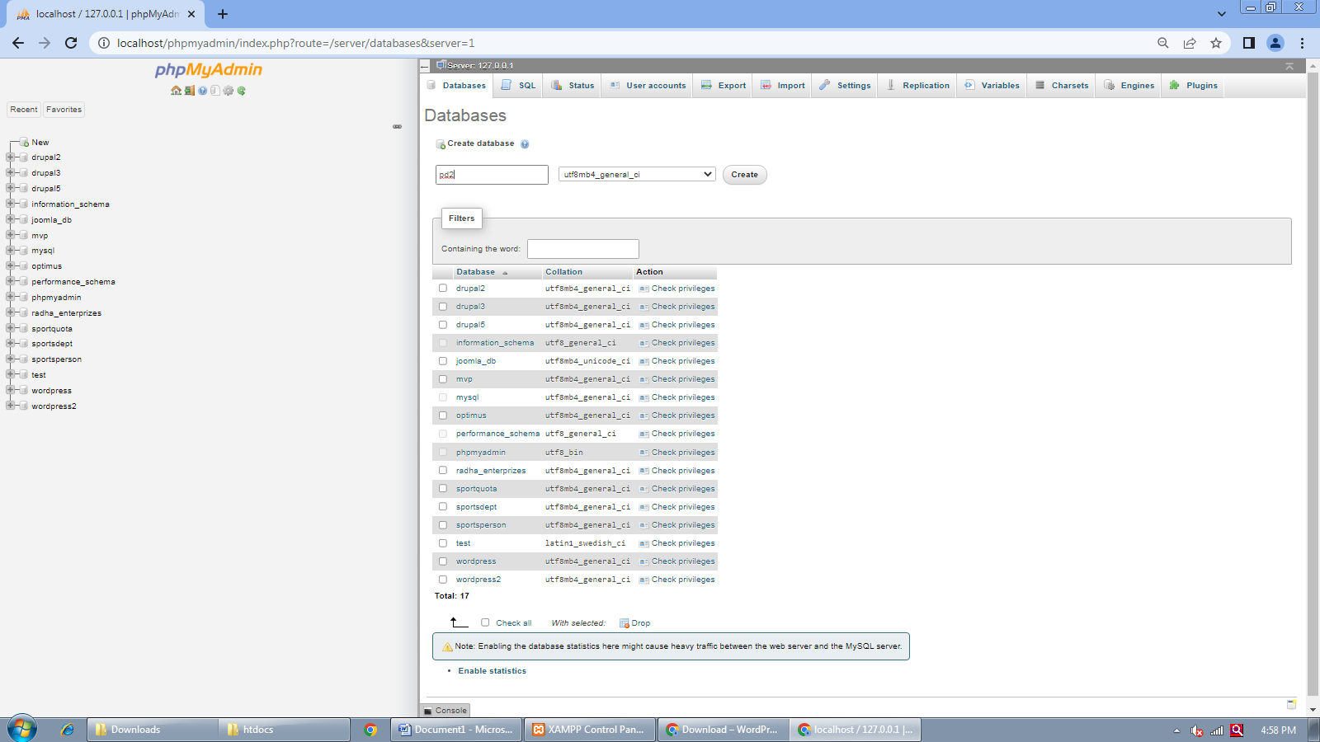

Step 4:- Run the installed script:-

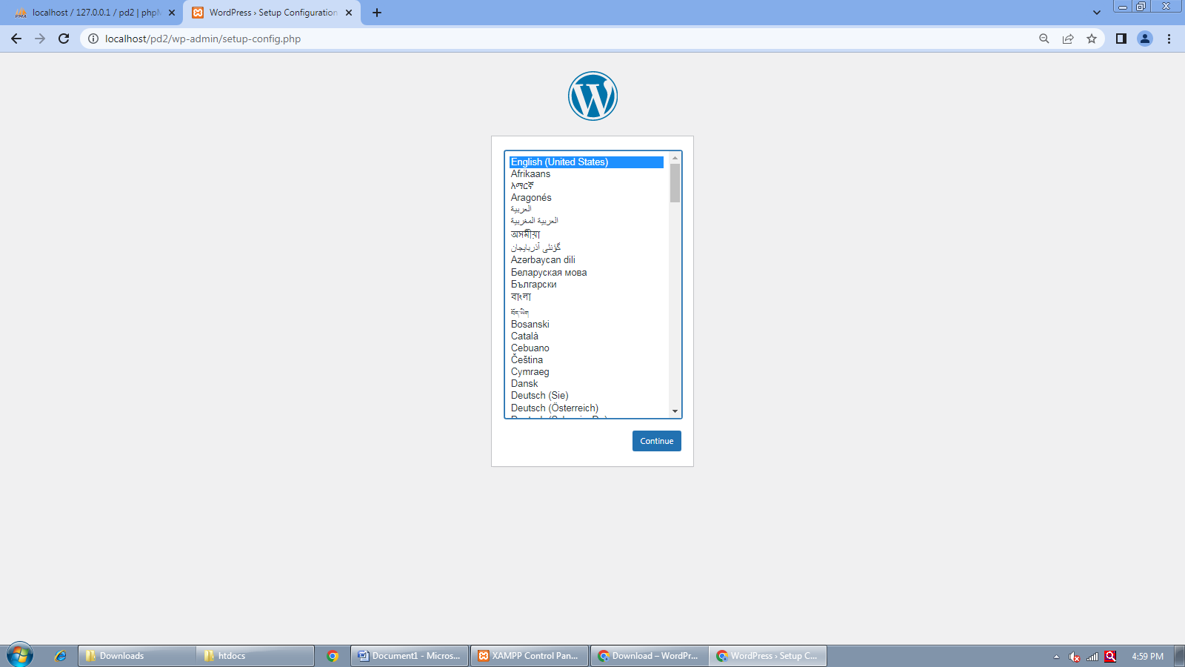

Step 5:- Setup Configuration File:-

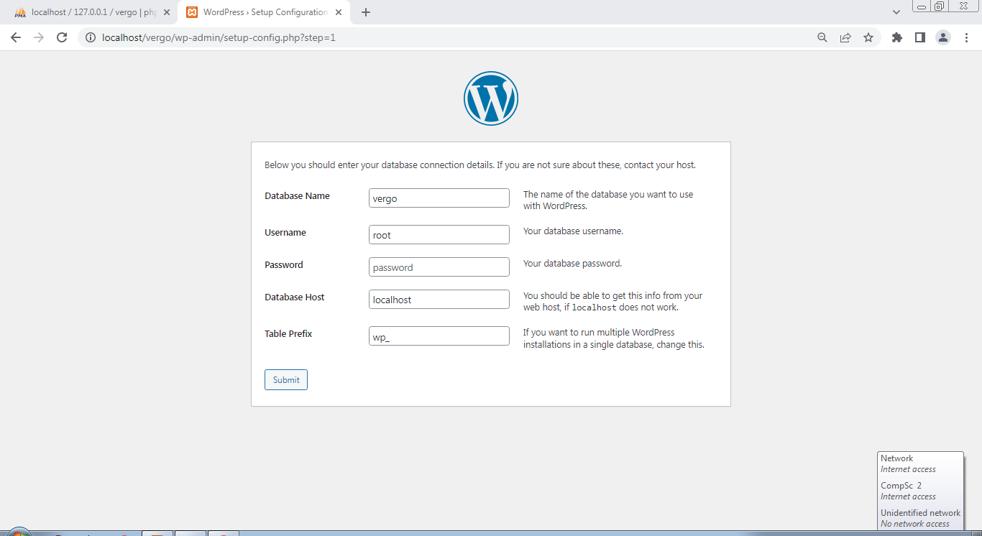

Step 6:- Site Details:-

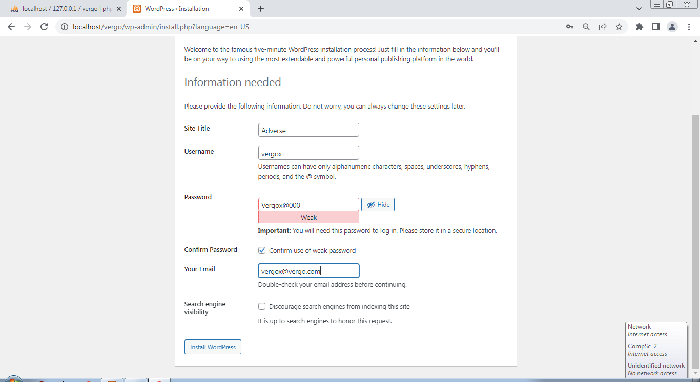

Step 7:- Finishing Installation:-

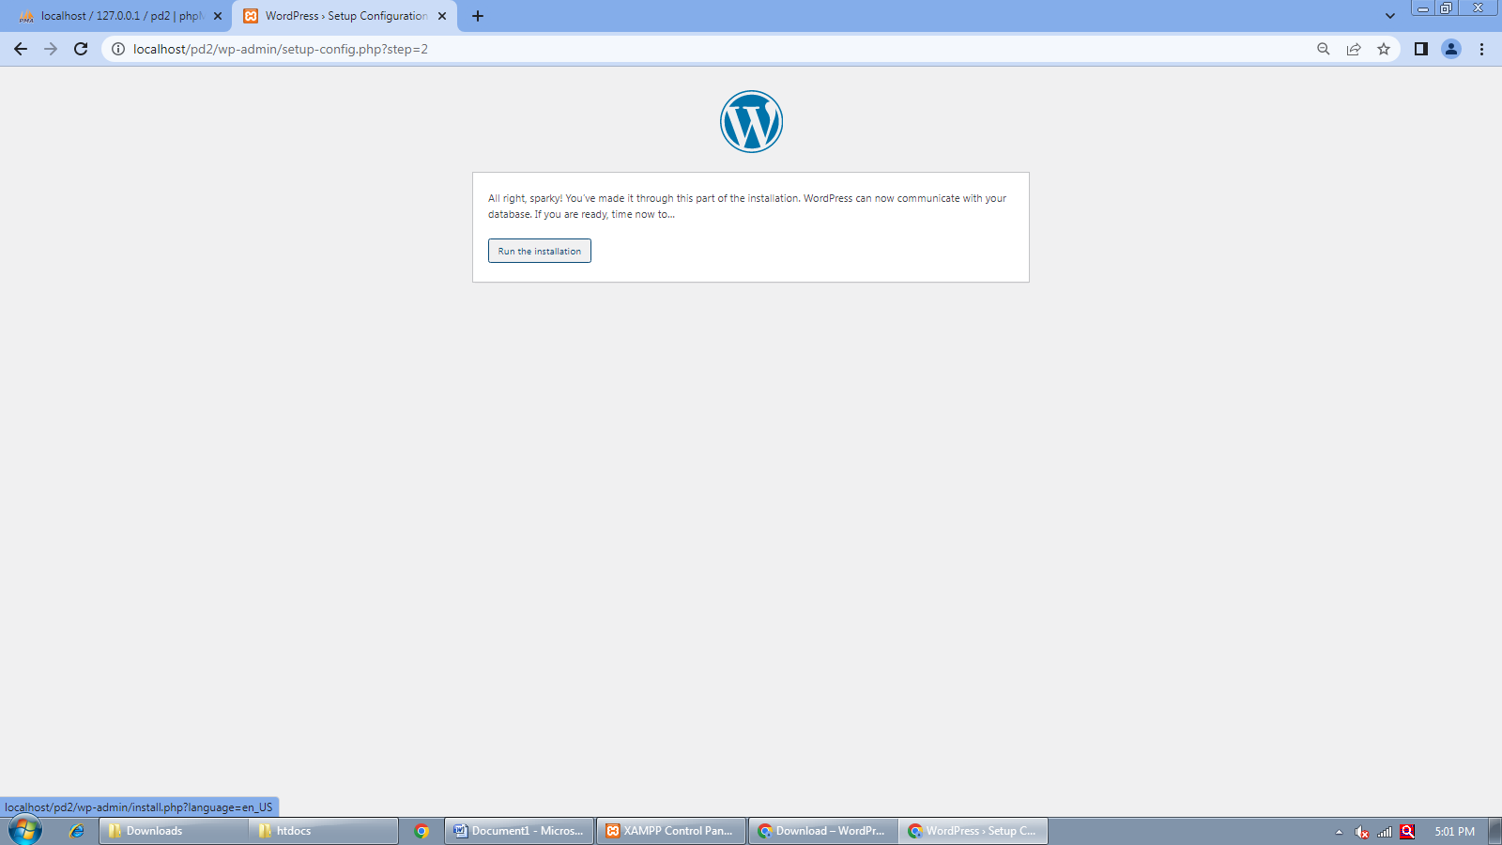

Step 8:- Ready to Login to Administration:-

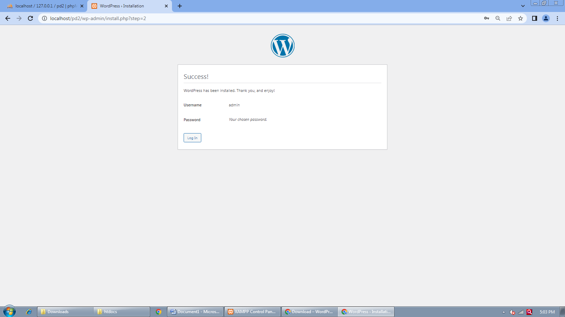

Step 9:- Welcome to Wordpress Dashboard:-

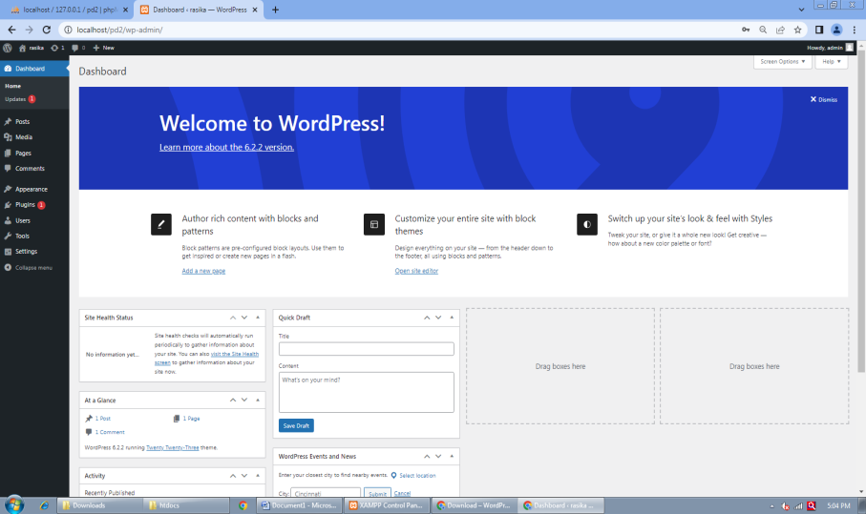

Step 10:- Front End:-

